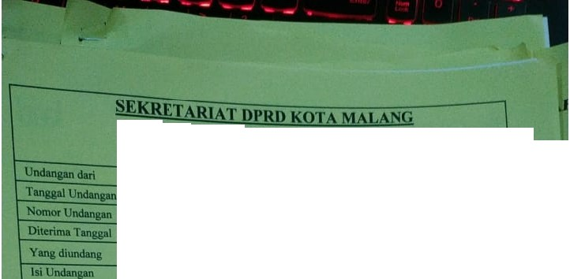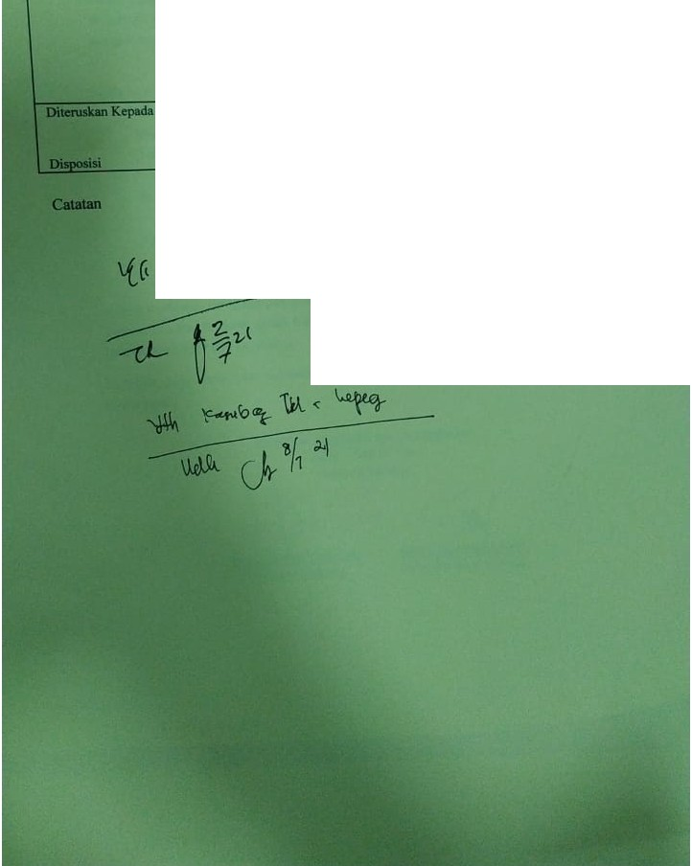

LIMBAR DISPOSISI UNDANGAN

* BlllkJltlm

# : 24Junl 2021

: 060/1693/MLQ.IALS.lUtDIBllT

# : 30Junl 2021

unc1anpn pdiedna pra pellllun dinlikeovw

Teiesa ntlkAndaymli p..ia:

"-d.8Jull 2021

pukul •09·00 Mmlmla

Bank

Aula Jathn di JA SupraplO No.26-21

211

, *p(4-. L* u-